First need to Create Key pair

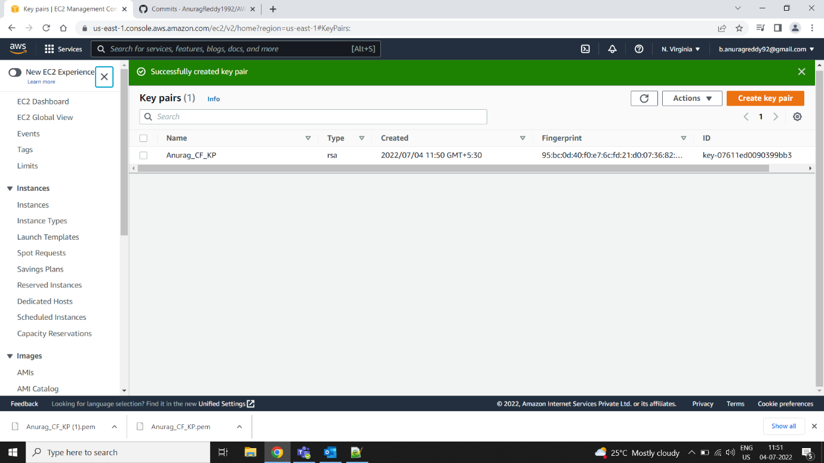

Need to give the key pair details in Json file

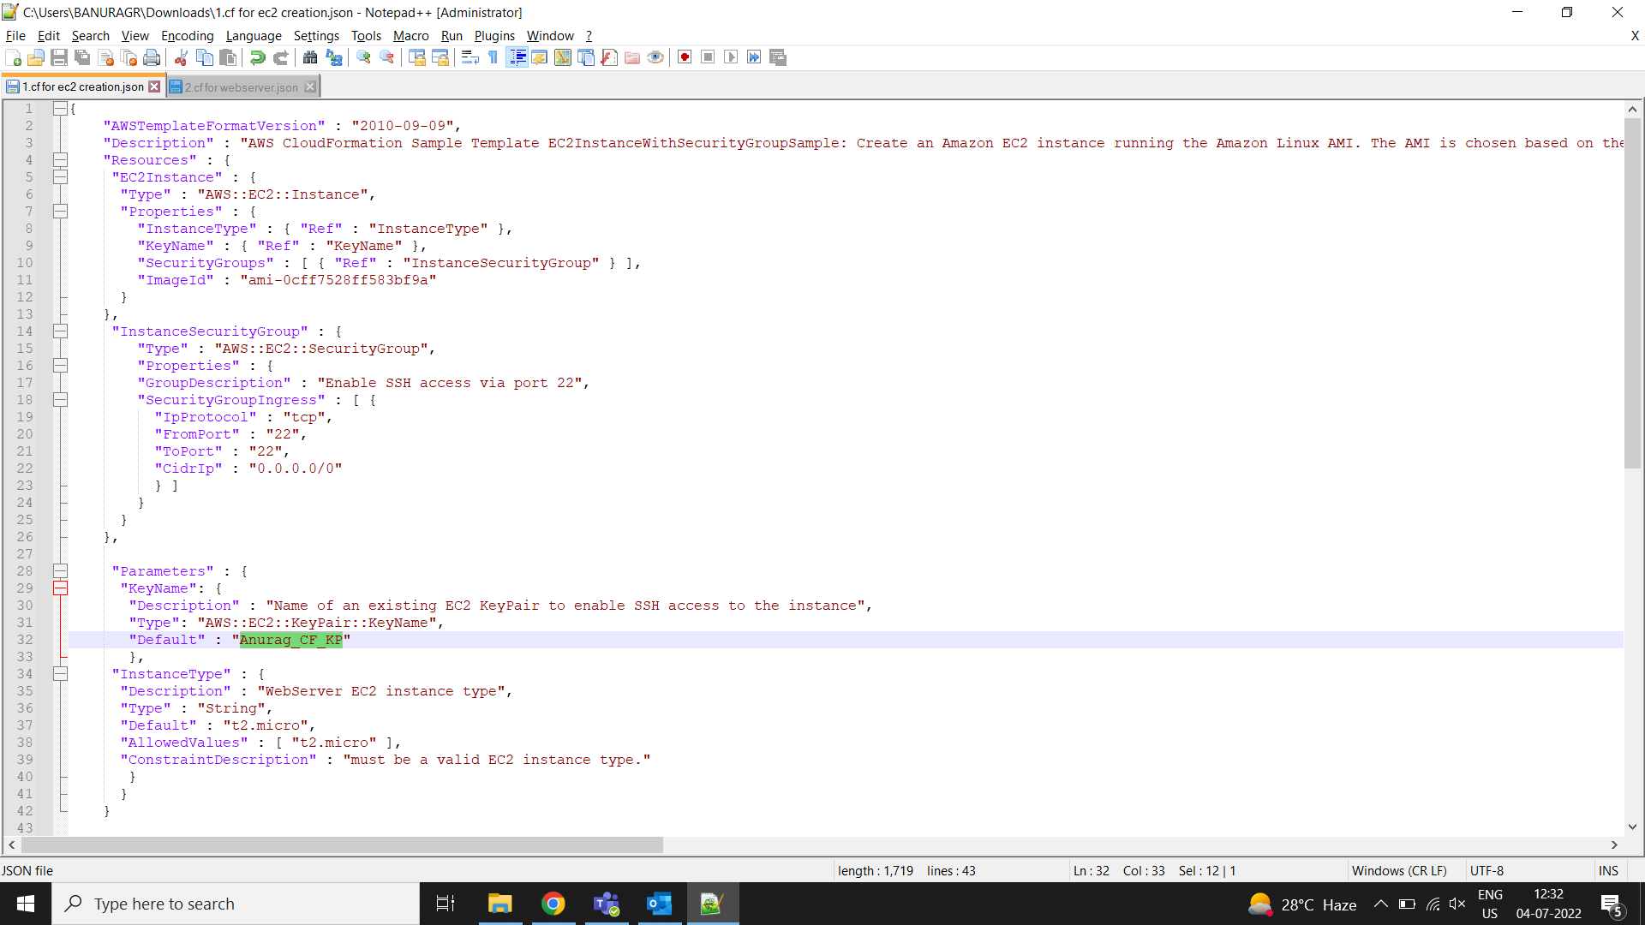

Then we need to provide AMI ID and Ports

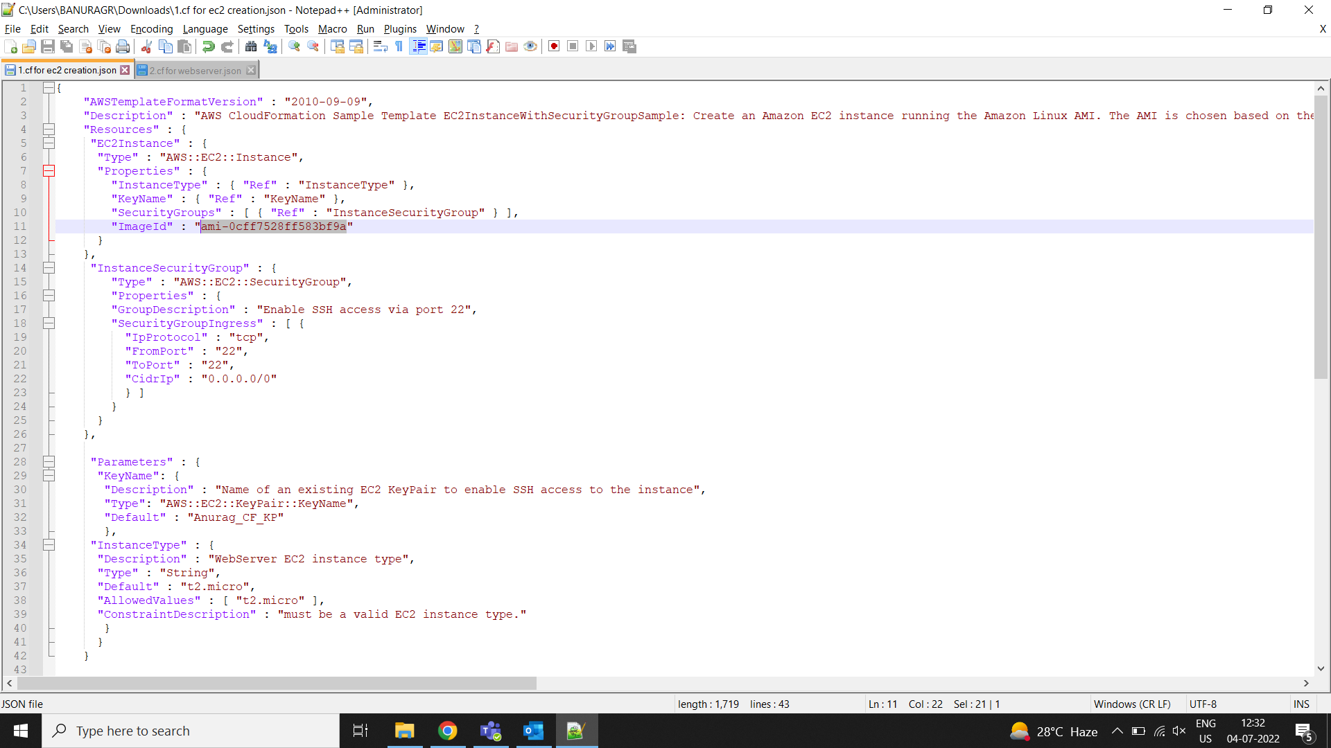

We need to go to [CloudFormation](https://us-east-1.console.aws.amazon.com/cloudformation/home?region=us-east-1#/) and we need to Create Stack and upload the Json file

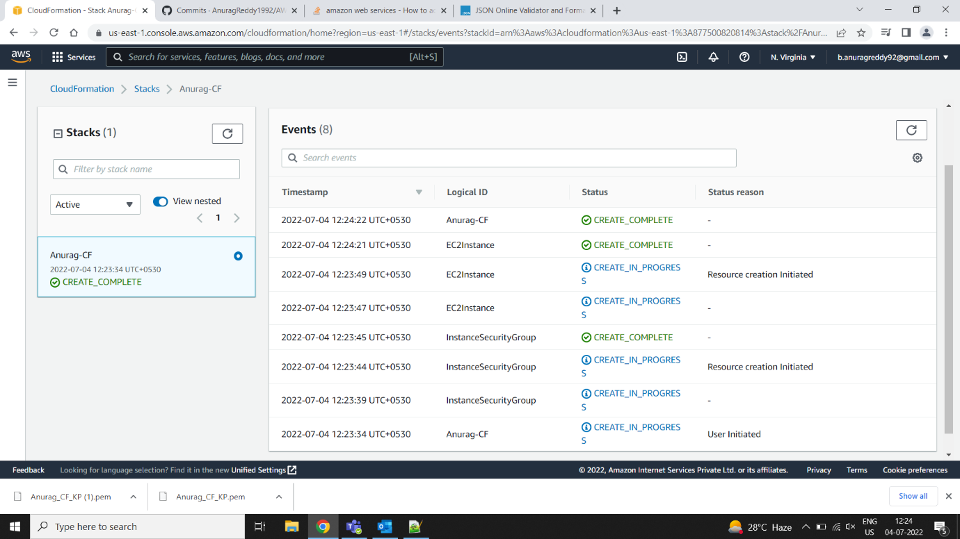

Check the EC2

